There are two exercises on structural business rules and conceptual entity-relationship diagrams in this assignment.

**Part 1: Artists and Songs**Review the following structural business rules regarding artists and songs to complete this part.

* An artist sings many songs.
* A song is sung by one or more artists.
* A song has a duration.
* A genre applies to at least 15 songs.

1. The business rules above specify all of the relevant entities needed for this exercise. To get started, list the names of all entities provided in the business rules above.

**Artist, Song, Duration, Genre**

2. The rules also specify all of the relevant relationships. Identify each relationship along with the entities it relates.

**ARTIST is related to SONG**

**SONG is related to DURATION**

**GENRE is related to SONG**

3. Some rules are not well formed in that they either do not describe both directions of the relationship, or they combine multiple relationships or entities into one statement. This can result in missing or ambiguous optionality and plurality constraints. Correct these rules by modifying them or adding new statements as necessary. You may make reasonable assumptions when doing so and there is no probably “right” list of assumptions; however, please state your assumptions.

* **An artist sings many songs.**
* **A song is sung by one or more artists.**
* **A song plays for a duration.**
* **A duration counts the time a song played.**
* **A genre applies to at least 15 songs.**
* **A song has a genre.**

4. Combine the original list of rules with your modifications to create a complete list of business rules. This combined list will not add additional entities, but will specify the optionality and plurality constraints for both sides of all relationships.

* **An artist sings many songs; A song is sung by one or more artists.**
* **A song must have a duration; A duration may last for 1 or more songs.**
* **A genre applies to 15 or more songs; A song must fit into one type of genre.**

5. Create a *conceptual* entity-relationship diagram using Crow’s Foot notation that reflects your list of business rules. You may use Microsoft Visio Pro, Lucidchart, or another similarly capable drawing application to produce your ERD. Note that cardinalities are not required in the diagram, though relationship connectivity notations are required.

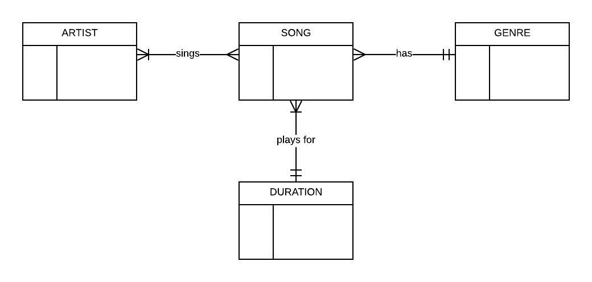

**Part 2: Car Repair Shops**

In this part, you will be repeating the same steps as in Part 1 for a more complex car repair shop scenario. Review the following business rules then complete the steps indicated below.

* Every car has a driver.
* Drivers drive one or more cars.
* A driver may schedule multiple appointments with multiple car repair shops.
* Each appointment is scheduled for one car.
* Each appointment results in a bill for the driver.

6. The business rules above specify all of the relevant entities needed for this exercise. To get started, list the names of all entities provided in the business rules above.

**Car, Driver, Appointment, Repair Shop, Bill**

7. The rules also specify all of the relevant relationships. Identify each relationship along with the entities it relates.

**CAR is related to DRIVER**

**DRIVER is related to APPOINTMENT**

**APPOINTMENT is related to REPAIR_SHOP**

**APPOINTMENT is related to CAR**

**APPOINTMENT is related to BILL**

8. Some rules are not well formed in that they either do not describe both directions of the relationship, or they combine multiple relationships or entities into one statement. This can result in missing or ambiguous optionality and plurality constraints. Correct these rules by modifying them or adding new statements as necessary. You may make reasonable assumptions when doing so and there is no probably “right” list of assumptions; however, please state your assumptions.

* **Every car has a driver.**
* **Drivers drive one or more cars.**
* **A driver may schedule multiple appointments**
* **An appointment is scheduled by a driver**
* **An appointment may be scheduled with multiple car repair shops.**
* **Each car repair shop may have 0 to many appointments available.**
* **Each appointment is scheduled for one car.**
* **A car may have one or more appointments scheduled.**
* **Each appointment results in a bill for the driver.**
* **A bill is generated for one or more appointments.**

9. Combine the original list of rules with your modifications to create a complete list of business rules. This combined list will not add additional entities, but will specify the optionality and plurality constraints for both sides of all relationships.

**Every CAR must have a driver; A DRIVER drives one or more cars.**

**A DRIVER may schedule 0 to many appointments; An APPOINTMENT must be scheduled by a driver.**

**An APPOINTMENT may be scheduled with 1 or more repair shops; Each REPAIR_SHOP may have 0 or more appointments available.**

**Each APPOINTMENT must be for working on one car; A CAR may have 0 or more appointments scheduled.**

**Every APPOINTMENT must result in a bill for the driver; A BILL is created for one or more appointments that a driver schedules.**

10. Create a conceptual entity-relationship diagram using Crow’s Foot notation that reflects your list of business rules. You may use Microsoft Visio Pro, Lucidchart, or another similarly capable drawing application to produce your ERD. Note that cardinalities are not required in the diagram, though relationship connectivity notations are required.

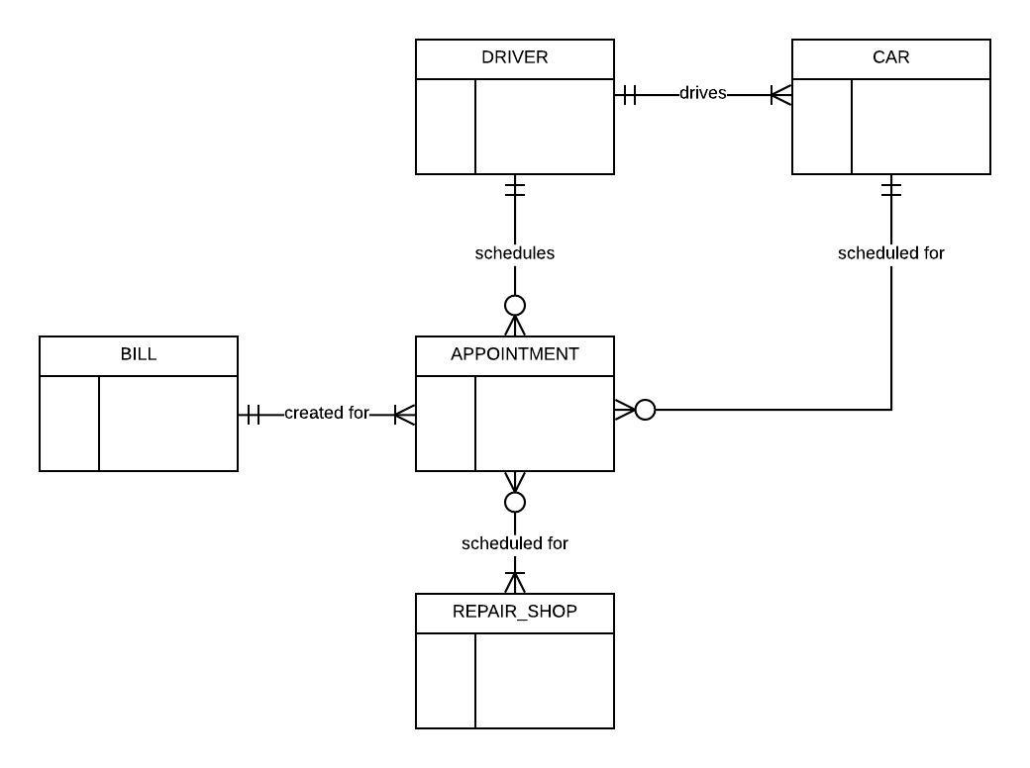



Your submission will be evaluated according to the following grading rubric.

|  |  |  |  |
| --- | --- | --- | --- |
|  | **Grade** | **Qualities Demonstrated by the Assignment Submission** | **Grade Assigned** |
| **Content (70%)**  **Measures the quality of the content in the assignment** | A+ ➔ 100 | The content demonstrates exceptional understanding of all relevant subject matter and its inter-relationships. All major relevant issues are thoroughly covered, and all content is very focused and on-topic. There is no known way to improve the content, and there are absolutely no technical or coverage errors present. |  |
| A ➔ 96 | The content demonstrates exceptional understanding of all relevant subject matter and its inter-relationships. All major relevant issues are thoroughly covered, and all content is very focused and on-topic. At most one insignificant technical or coverage error may be present |
| A- ➔ 92 | The content demonstrates deep understanding of all relevant subject matter and its inter-relationships. All major relevant issues are covered, and all content is on-topic. |
| B+ ➔ 88 | The content demonstrates understanding of all relevant subject matter and its inter-relationships. Almost all major relevant issues are covered, and the content is at least reasonably on-topic. |
| B ➔ 85 | The content demonstrates understanding of most relevant subject matter and its inter-relationships. Almost all major relevant issues are covered, and all content is at least reasonably on-topic. |
| B- ➔ 82 | The content demonstrates moderate understanding of much relevant subject matter and its inter-relationships. There is reasonable coverage of major relevant issues, and the content is at least reasonably on-topic. |
| C+ ➔ 78 | The content demonstrates some understanding of relevant subject matter and its inter-relationships. Some major relevant issues are covered, and at least some content is on-topic. |
| C ➔ 75 | The content demonstrates understanding of a small portion of the relevant subject matter and its inter-relationships. Some major relevant issues are covered, and at least a small portion of the content is on-topic. |
| C- ➔ 72 | The content demonstrates little understanding of and insight into the relevant subject matter and its inter-relationships. A small portion of the major relevant issues are covered. The focus of the content may be off topic or on insubstantial or secondary topics |
| D ➔ 67 | The content demonstrates almost no understanding of or insight into the relevant subject matter and its inter-relationships. Almost none of the major relevant issues are covered, and the content may be almost entirely off-topic. |
| F ➔ 0 | The content demonstrates no understanding of or insight into the relevant subject matter and its inter-relationships. No major relevant issues are covered, and the content is entirely off-topic. |
| **Exposition (30%)**  **Measures how well the content is expressed** | A+ ➔ 100 | The presentation of all ideas and designs is exceptionally clear and persuasive; the entire submission is exceptionally organized. There is no known way to improve the clarity or organization of the submission. |  |
| A ➔ 96 | The presentation of all ideas and designs is exceptionally clear and persuasive; the entire submission is exceptionally organized. There may be at most one insignificant way to improve the clarity or organization of the submission. |
| A- ➔ 92 | The presentation of all ideas and designs is very clear and persuasive; the entire submission is very organized. |
| B+ ➔ 88 | The presentation of all ideas and designs is clear and persuasive; the entire submission is organized. |
| B ➔ 85 | The presentation of most ideas and designs is clear and persuasive; most of the submission is organized. |
| B- ➔ 82 | The presentation of most ideas and designs is generally clear; most of the submission is reasonably organized. |
| C+ ➔ 78 | Some parts of the submission are hard to understand; some parts are disorganized. |
| C ➔ 75 | About half of the submission is hard to understand; about half is disorganized. |
| C- ➔ 72 | Most parts of the submission are hard to understand; most parts are disorganized. |
| D ➔ 67 | Almost all of the submission is hard to understand and disorganized. |
| F ➔ 0 | The entire submission is hard to understand and disorganized. |